Subject: Memo on Applying NLP Techniques to CEO Letters for Economic Analysis

Dear Recipients,

I am writing to brief you on a recent project that applies Natural Language Processing (NLP) to the annual letters written by Jamie, Dimon, the CEO of JPMorgan & Chase, a leading global financial institution, to its shareholders. The CEO's letters offer valuable insights into the economy and our project aims to systematically harness this information.

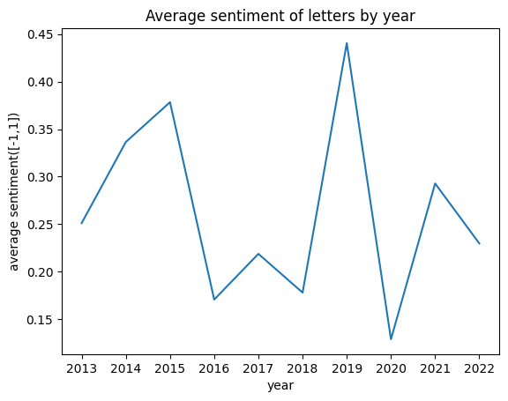

The methodology includes three steps:

1. **Sentiment Analysis Using pre-trained distilBERT**: The project used a pretrained distilBERT model to determine the overall sentiment of each letter. This NLP model effectively captures the context and nuances of language, enabling us to convert textual data into a quantitative sentiment score.
2. **Topic Extraction Using TF-IDF**: We've employed the TF-IDF technique to identify key topics discussed in each letter. TF-IDF, or Term Frequency-Inverse Document Frequency, is a statistic that reflects how crucial a word is to a document within a collection of documents.

|  | **1st** | **2nd** | **3rd** | **4th** | **5th** | **6th** | **7th** | **8th** | **9th** | **10th** |
| --- | --- | --- | --- | --- | --- | --- | --- | --- | --- | --- |
| **2013** | new | capital | us | clients | business | bank | banks | assets | global | financial |
| **2014** | banks | business | bank | capital | crisis | clients | company | new | one | market |
| **2015** | banks | clients | us | new | bank | business | capital | people | many | one |
| **2016** | capital | bank | banks | would | business | growth | us | companies | many | new |
| **2017** | business | us | years | growth | people | bank | new | jpmorganchase | would | company |
| **2018** | many | us | banks | new | jpmorganchase | would | capital | business | growth | issues |
| **2019** | crisis | customers | us | bank | employees | businesses | one | jpmorganchase | business | clients |
| **2020** | us | covid | people | need | banks | many | new | capital | world | would |
| **2021** | need | us | banks | global | also | world | billion | people | company | capital |
| **2022** | banks | us | business | also | bank | company | economic | need | market | global |

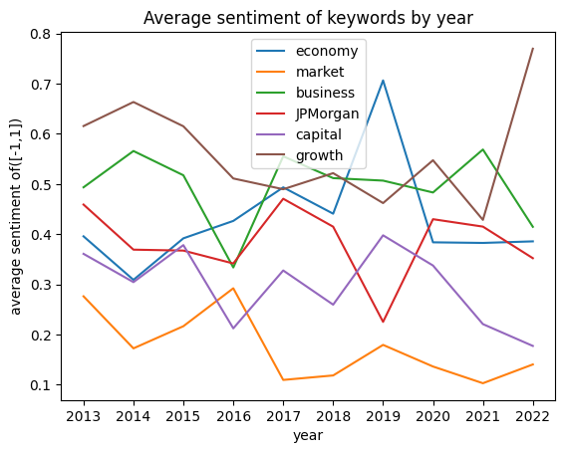Graph: Ranked Keywords by year of letter

1. **Target Sentiment Analysis using NewsMTSC**: After identifying key topics, we've conducted a targeted sentiment analysis to gauge the sentiment towards each individual topic. This provides us with a nuanced understanding of the Jamie Dimon’s views on various economic matters.

The insights generated from this analysis could aid in policy formation and decision-making by providing an understanding of US economic trends as perceived by a leading figure in the finance industry.

I recommend the examination of these findings and consider integrating them into our economic forecasting and strategy planning.

Best regards,

Duoji Jiang